January monthly report
Project Title:
Conversion of post-combustion gas from cement manufacturing to syngas by electrochemical CO₂ capture and reduction
……..........................................................
Dr. Pongkarn Chakthranont
Sothearoth Heng
NCR ID: 803198
Under the supervision of
Dr. Pongkarn Chakthranont
Contract Number: NCR-NN-2024-22237-EN
January 2025

- Tasks list for December
- Long-term stability under a pure CO₂ with 0.25M KOH electrolyte at 200mA/cm²
- Long-term stability under a diluted 15%CO₂ with 0.25M KOH electrolyte at 100mA/cm²
- Long-term stability under flue gas conditions
- Testing 25cm² electrolyzer under an optimum 5cm² electrolyzer condition

- Experimental Procedure
Long-term stability of CO₂ electrolysis
A 5 cm² MEA electrolyzer was used to evaluate the CO2RR performance under modulated operating conditions. The Ni foam, bipolar membrane (BPM), and different cathode catalysts were employed as the anode, membrane, and cathode electrode, respectively. 500 ml of 0.5 KOH was recirculated and used throughout the experiment as the anolyte at 8 ml/min. The KOH electrolyte was refreshed every 24h, while the NiSAC cathode was also flushed with 10ml of DI water. The humidified CO₂ gas stream was introduced into the cathodic inlet under total flow rates of 10 ml/min. Meanwhile, the cathodic outlet was directly injected into an online gas-chromatography for gas products analysis.

- Results
Long-term CO₂ electrolysis of Ni0.5SAC under 150ml/min CO₂ with 0.25M KOH and IrO₂-TiPt mesh at 200mA/cm²
Previously, the long-term stability of a pure CO₂ condition at 200 mA/cm² with a 1M KOH anolyte and Ni foam was disrupted by massive salt formation on the cathode side after 8 hours of operation. Interestingly, when a diluted 0.25M KOH anolyte and an IrO₂-TiPt anode were used, the overall cell performance sustained an FE(CO) of up to 90% for 14 hours without any salt formation on the cathode side. However, the cell voltage marginally increased over the operational duration, indicating other factors, such as the loss of hydrophobicity, degradation of GDLs, surface changes in the catalyst, or changes at the catalyst-membrane interface, which might have caused a decline in overall cell performance over time.
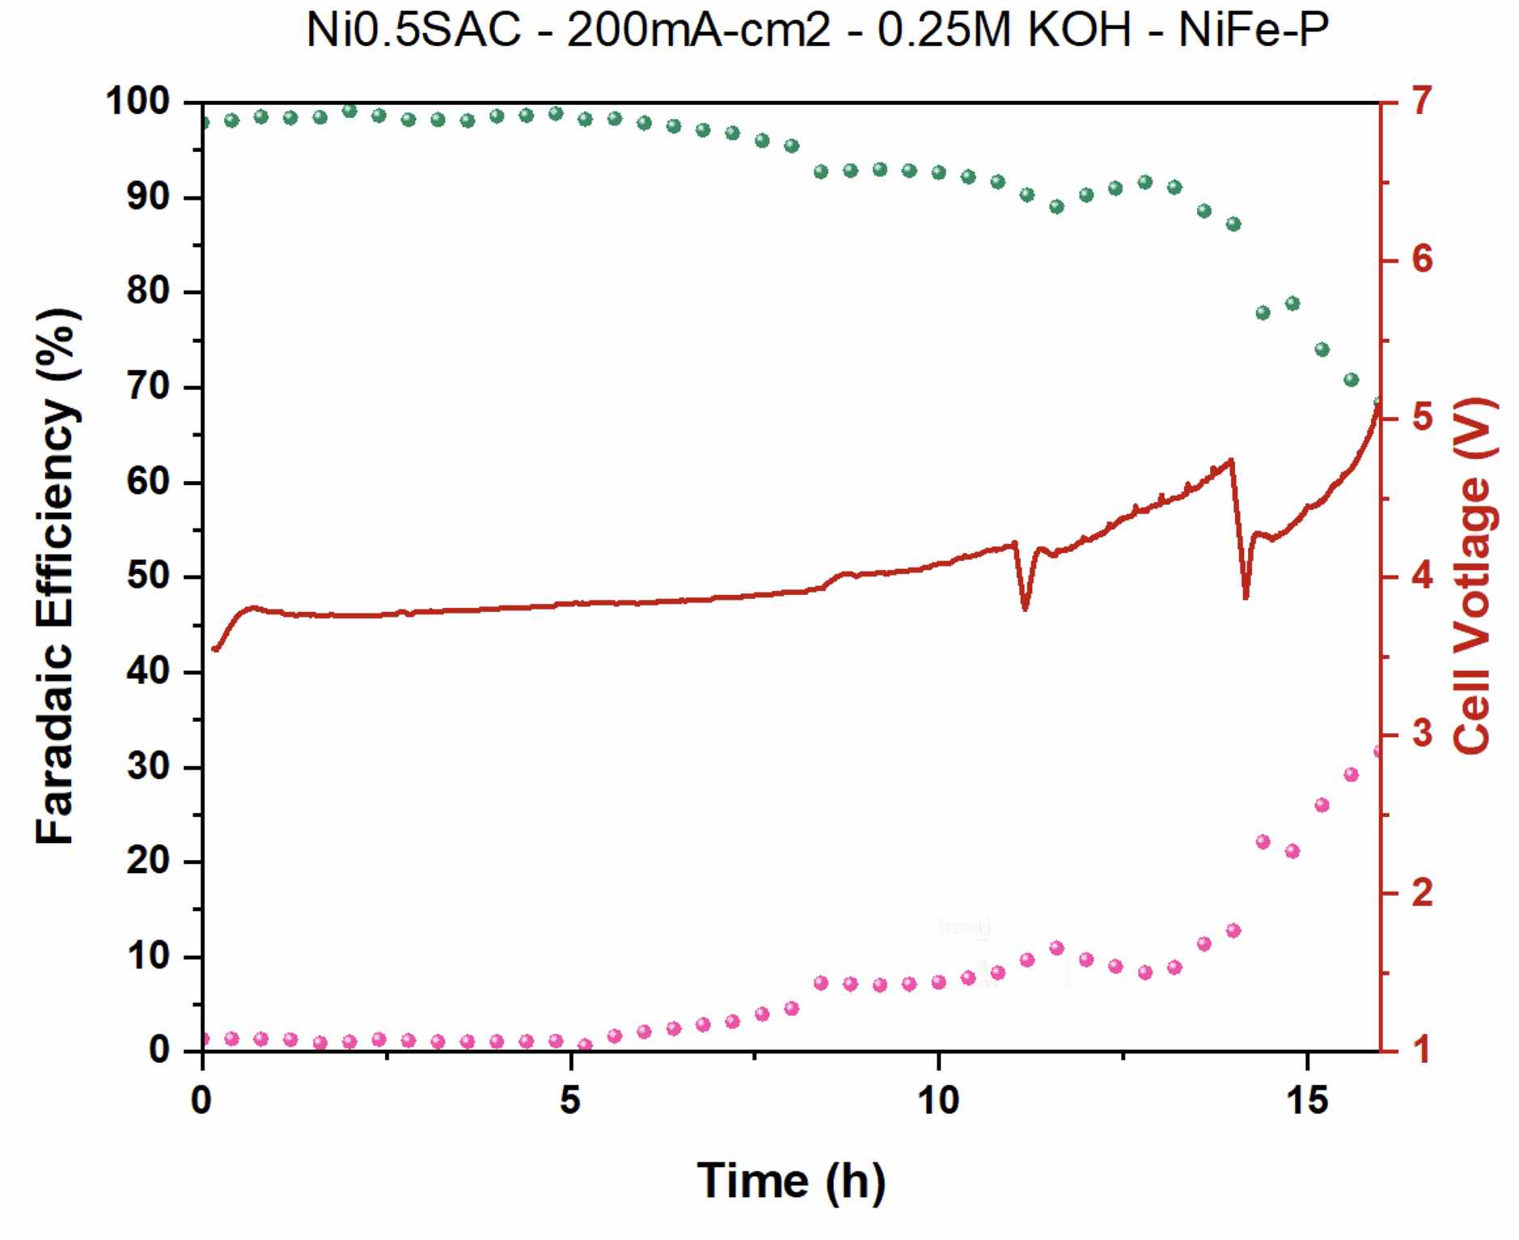
Figure 1. Long-term CO₂ electrolysis of Ni0.5SAC under a pure CO₂ with 0.25M KOH and IrO₂-TiPt at 200mA/cm²

Long-term CO₂ electrolysis of Ni0.5SAC under 20ml/min SFG (15%CO2, 5%O2) at 100mA/cm²
The long-term stability of Ni0.5SAC under a SFG condition was conducted at 100mA/cm² as shown in Fig. 2. As expected, the oxygen reduction reaction (ORR) was predominantly took place at a low operating current density. Moreover, the FE(CO) was achieved for up to 30% over an operational duration of 24h. Therefore, a higher current density should be applied to maximize either the CO₂ utilization or syngas product.
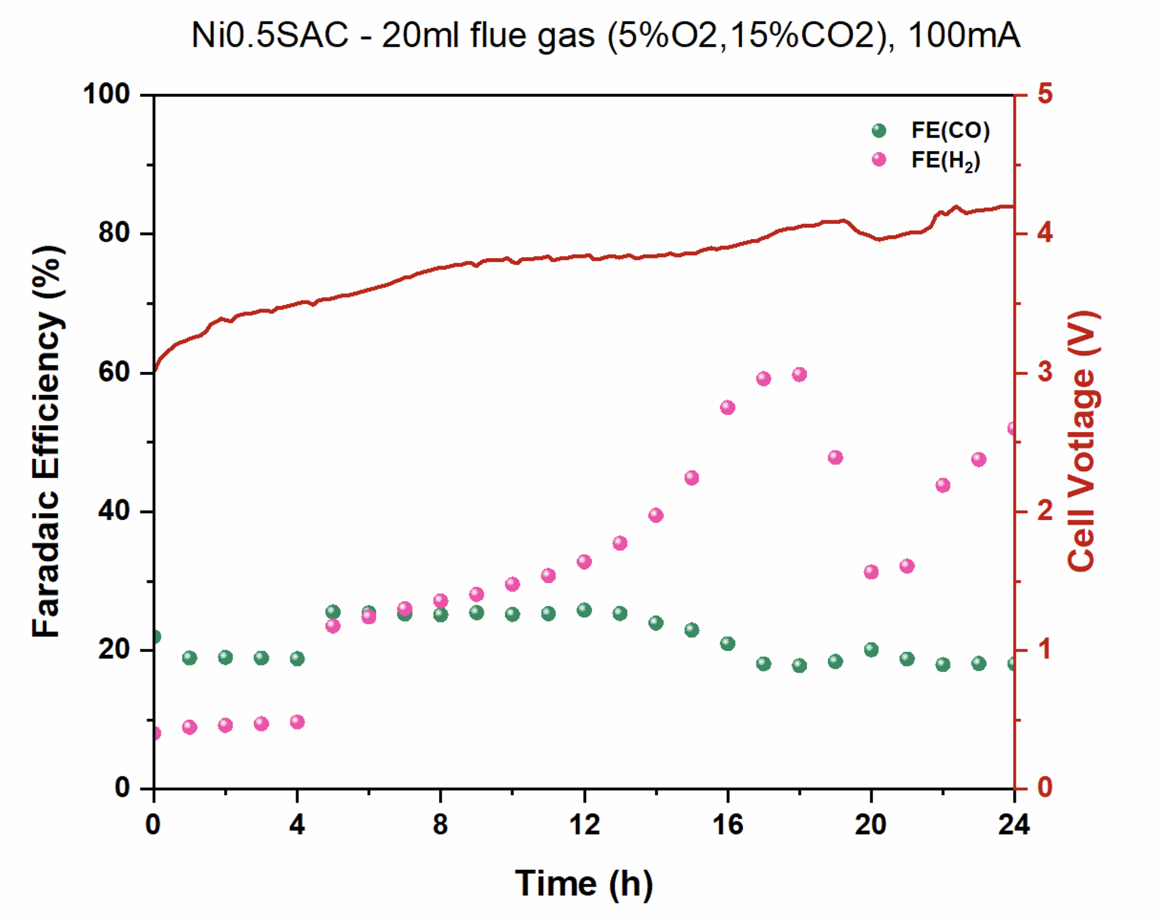
Figure 2. Long-term CO₂ electrolysis of Ni0.5SAC under a SFG with 0.25M KOH and IrO₂-TiPt anode at 100mA/cm²

Long-term CO₂ electrolysis of Ni0.5SAC under 15%CO₂ at 100mA/cm² with 0.25M KOH and IrO₂-TiPt anode
By using a diluted 0.25M KOH with an IrO₂-TiPt anode, we could prolong the stability of the overall cell performance from 15h to 35h operational duration with a maximum FE(CO) of 84% and an average full-cell voltage of around 3.85V.
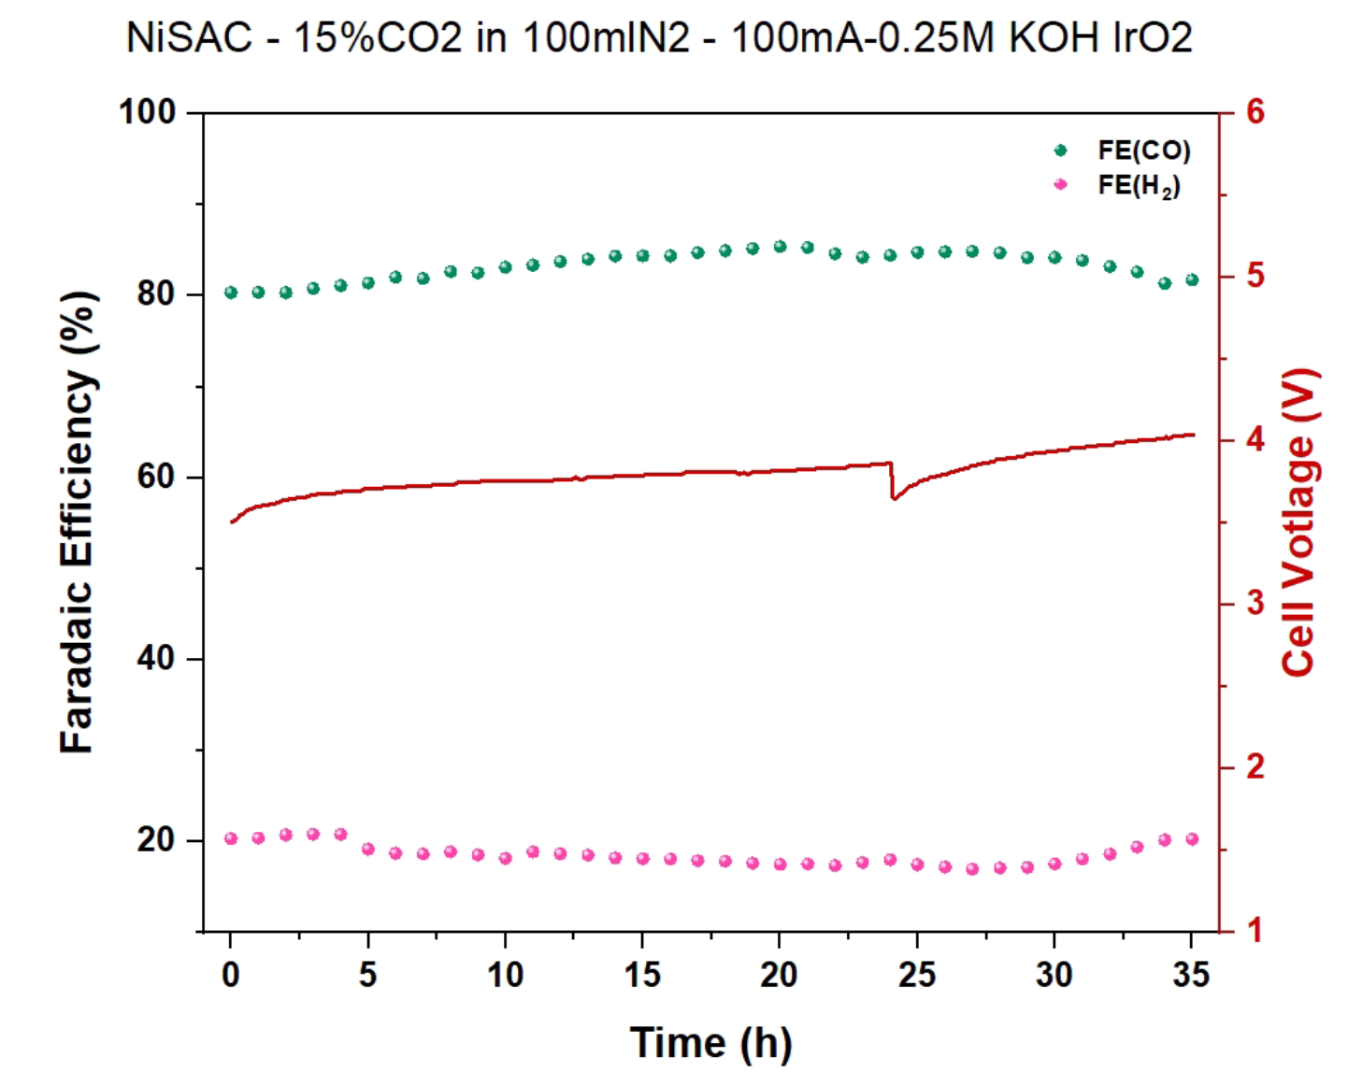
Figure 3. Long-term CO₂ electrolysis of Ni0.5SAC under a diluted 15%CO₂ with 0.25M KOH and IrO₂-TiPt anode at 100mA/cm²

Short-term CO₂ electrolysis of NiSAC under 150mlCO₂ with 1M KOH and Ni foam at 100mA/cm²
To evaluate the feasibility of deploying the optimum conditions from a 5 cm² electrolyzer to a larger 25 cm² electrolyzer, a short-term stability test of the 25 cm² electrolyzer was conducted under the same optimum pure CO2 conditions as the 5 cm² electrolyzer. As shown in Fig. 4, the maximum FE(CO) of >90% was maintained at 100 mA/cm² for 3 hours, with the full-cell voltage slightly higher than that of the 5 cm² electrolyzer. These results demonstrate that the optimum conditions obtained from a small-scale electrolyzer are both useful and viable for a larger-scale electrolyzer. However, other parameters, such as reaction kinetics, heat transfer, and more, need to be investigated further to improve overall cell performance and stability.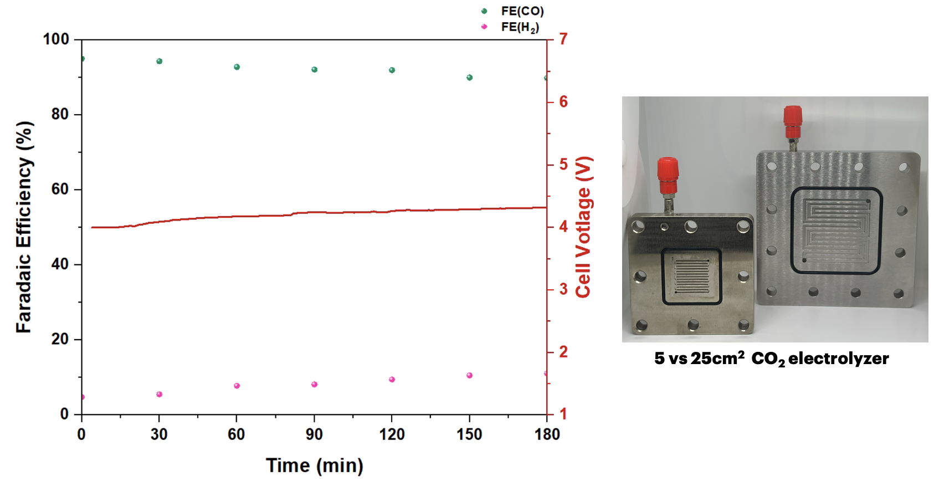
Figure 4. Short-term CO₂ electrolysis of Ni0.5SAC under a pure CO₂ condition at 100mA/cm²

- Upcoming tasks
- Characterization of NiSACs
- Long-term stability under high CO₂ conversion conditions (diluted and pure CO₂ conditions with lower flow rates)
- Long-term stability under SFG conditions at 200mA/cm²
- Optimization of the 25cm² CO₂ electrolyzer operating condition:
  - Torque force
  - Cathodic/Anodic flow rate
  - Current density
  - Catalyst mass loading

